CREATIVE PRNTERS
END OF TERM III EXAMINATION PRIMARY THREE  LITERACY 1B | 2024
Time Allowed: 2hours 15 minutes

Name: TEACHER B.E.K
______
___
School: NEW MODEL PRIMARY SCHOOL Class: PRIMARY THREE
_______
__
______
For Examiner’s
A
B
TOTAL

SECTION A
1. Name any one leader in your community.
- Teacher,
- President,
- Members of Parliament,
- Reverend,
- Priest,
- Chair person, e.t.c

2. Name the direction in which the sun rises.

- East /eastern direction
3. What is child abuse?

- Child abuse is the violation of children’s rights
4. How are Nimbus clouds useful to farmers?

- They provide rain to farmers
5. Draw and name one craft used at home.

6. Why do people keep birds at home?

- For egg production.
- For meat production.
- To get feathers.
- To get money after selling
7. Give one leader found at home.

- Father /Mother /Grandfather/Grandmother.
8. How is a school important in our community?

- It provides education to children in the community.
- It creates a market for goods in the community
- It creates jobs to people e.g. teachers, matrons, gatekeepers nurses cooks etc,
9. Mention any one basic need of children.
- Food /clothes/shelter/medical care/water etc

10. Name this material found in a classroom.
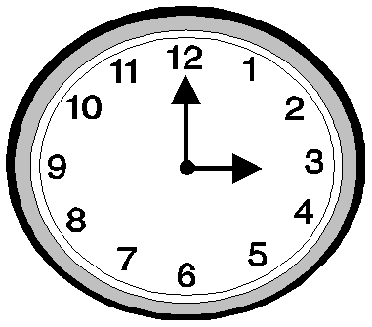

- Wall clock
11. State any one role of a father at home
Pays school fees for children.
Pays home bills e.g. Water bills.
Provides basic needs at home
Provides security
Disciplines children
12. Give the importance of social activities in our community.

- They promote morals among people / they promote unity /they preserve culture
13. How is the item below useful at home?
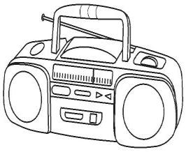 For communication/ the radio advertises our things /for entertainment.
14. State any one right of children.
- A right to food
- A right to education
- A right to shelter
- A right to have a name etc

15. Give one means of road transport.

- Buses/cars/ lorries/taxies/ motorcycles/bicycles/Pedestrians, etc.
16. How do children promote peace at school?
- By following rules and regulation
- By respecting one another
- Respecting teacher
17. Name one recreation activity done at home.

- Swimming/dancing/watching films/jogging/reading novels
18. Write one type of family you know.
- Nuclear family/extended family/foster family
19. Give any one cardinal point of a compass.
- North/east/south/west

20. What is an economic activity?
- An economic activity is the work done by people to get money.
21. Name one social service provided by doctors.
- Health service

22. Write UWEC in full.

- Uganda Wildlife Education Centre

23. How is dressing an important cultural practice?
- It promotes culture
- Promotes safety
- Promotes comfort
24. Give any one indicator of peace among people in a society.
Unity amongst people/happiness amongst people /development in an area/disease free

25. Why do we need leaders in our community?
To guide and control us/to maintain security/to settle disputes

26. Mention any one cultural practice among the Baganda.
Greeting /paying bride price /marriage

27. Name the type of weather drawn below.

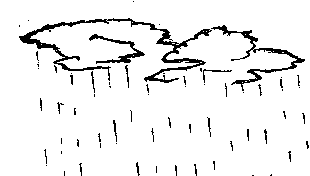 Rainy weather
28. Why do children need holidays?
- To relax
- To help their parents in work
29. Name one group of people that work in a school.
- Teachers /cooks/nurses/matrons patrons
30. Mention the school symbol that directs people to a school.

- School signpost
31. Name one thing found in a good home.
- Toilet /rack/ kitchen /rubbish pit/water source

32. How do people meet their needs in our community?
- By working hard
- By trading
- By begging
33. Give any one example of a temporary house.
Tent

34. How is the item drawn below useful at school?


For communication/for time management/for scheduling

35. Give any one element of a good map.
A good map should have;
- A key
- A compass direction
- A scale
- A frame
- A title
- A boundary

36. State one example of a class rule in your class.
- No going out during lessons
- No playing in class
- No dodging lessons
- No making noise in class
- Sit upright in class
- Be active in class
- Pay attention during lessons
- Write in good handwriting
- Always keep the classroom clean

37. Where do sick pupils go for treatment?
- Hospitals/clinics/dispensaries/pharmacies

38. Write one example of school property.
- Text books/ furniture /school uniform / school buildings

39. Give one term used to mean things that surround man.

- Environment
40. Mention one example of a semi-cardinal point.
- Northeast /southeast/northeast/northwest/ southwest

SECTION B
41. a) What is a resource?
- A resource is anything man uses to satisfy/meet his needs.

b) Give any two examples of resources in the environment.

- Minerals/ land/water
c) How is water useful at home?

- It is used for washing clothes and utensils / it is used for cooking
- It is used for bathing./It is used for making juice.
42. a) Mention any two things found in a good house.
- Bedrooms/dinning / cupboards /furniture /bathroom
b) How do parents take care of their children?
By providing them with basic needs e.g. food, clothes etc.
By providing them with security
By giving them scholastic materials

c) Why do people build fences around their homes?
- For security and safety

43. a) Name any two animals kept in the zoo.

i) Elephant/zebra/leopard/tiger etc.

b) Why do people keep animals at home?

- To get money after selling
- To get meat
- To get manure/fertilizers

c) State one way of caring for animals.
- By providing them with water and pasture
- By providing them with shelter
- By vaccinating them
- By deworming them

44. a) What is the role of the police in a community?

- To keep law and order
b) Apart from the police, give any other two groups of people who keep
security in our community.

i) Community leadCommunity leaders/ local defence units (LDUs)

c) How do we keep security at school?
- By following rules and laws at school
- By respecting fellow learners and teachers
- Reporting strange people
- Installing security cameras
- By fencing the school
- By employing security guards
45.
A   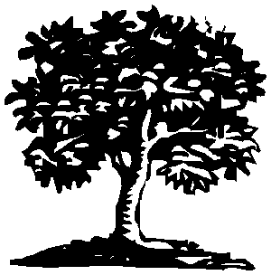 B 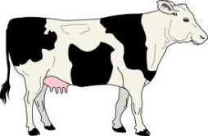 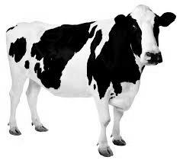
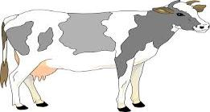

a) Name the projects marked with letters A and B.

A Tree planting B Dairy farming
b) Name one thing needed to start a project.

- Capital
- Time
- Land
- Market
- Management
- Labour
- Knowledge and skill
- Water
c) Give one benefit of a project.
- It is a source of employment
- A project is a source of income
- It develops skills and knowledge
46. a) Name any two things made from local materials.

Pots/ baskets/ ropes/ balls/ mats/ hats etc
b) How is a ball useful to children?

- It is used for playing with
- c) Why do people make crafts?
- Some are used for decoration
- To get employment
- To get money
- Some are used for wearing e.g. hats

47. a) Name the two seasons in a year.
- Wet season
- Dry season
b) Give one activity done in the wet season.
- Planting of crops
- Weeding
- Pruning
- Spraying
c) Why do people harvest crops in the dry season?
- There is enough sunshine to dry their harvested crops

48. a) Mention any two things a school can get from its neighbours.

Food
Children/learners
Security
Furniture
Workers

b) Give one cause of problems between a school and its neighbours.
- Theft
- Noise from the school
- Trespassing
- Poor sanitation
- Use of abusive language by pupils
c) How can a school prevent problems with its neighbours?
By fencing the school to prevent trespassing
By counselling its learner to stop using abusive language
The school should participate in the general cleaning of the community
49. a) State two activities done by children to help their parents.

Fetching water
Fetching firewood
Washing utensils
Carrying babies

b) Why do children help their parents at home?
To show them love
To show them respect
To promote cooperation at home
c) Draw and name one item used to clean a house.

-broom
-rag
-water

50. a) What is transport?
- Transport is the movement of people and goods from one place to another.

b) Give any two means of road transport.
- Buses /cars / taxies / Lorries bicycles /motorcycles/pedestrians

c) State any one unsafe way of using the road.
- Not following road signs
- Using vehicles in poor condition
- Not crossing busy roads on the zebra crossing
- Playing on the road
51. a) Mention any two elements of a good map.
A key
A compass direction
A scale
A frame
A title
A boundary
b) Name the map symbols shown below.

__
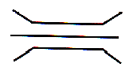

i) _
A bridge

A hill
ii)


52. a) What is Communication?
- Communication is the sending and receiving of messages

b) Mention one example of a radio station you know.
Central broadcasting service (CBS)/Centenary fm/ Bukedde fm/ Beat fm /Capital fm

c) Draw and name two means of communication.

Drum/television telephone/newspapers

53. a) Name the places where these leaders are found.
i) Head teacher -School
ii) Reverend - Church
b) State any two qualities of a good leader.
A good leader should be;
Able
Kind
Honest
Faithful
Exemplary
Approachable
Trustworthy
Knowledgeable
Tolerant
Respectful
God fearing
Hardworking
54. a) Name any lake well know for salt mining in Uganda.

- Lake katwe
b) Why are fishmongers useful to our community?
- They sell fish to people

55. a) What is a home stead?
- A homestead is a home and its surroundings
b) Why do people build houses?
- For security/protection
- It shows responsibility
- To get respect
c) Draw and name two buildings materials for a permanent house.

Stones iron sheets

END

